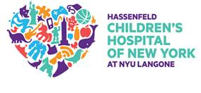

Off to

COLLEGE ?



This is an event for teens and parents to learn more about navigating diabetes management while preparing to go off to college for the first time.

**Event Date :** April 4th 2017

**Time:** 5:00-7:00PM

**Location :** NYU Child Study Center

1 Park Avenue

New York, NY 10016

7th Floor – Central Park Room

**REFRESHMENTS WILL BE SERVED**

Please RSVP to Morgan Pacheco, diabetes social worker, by March 31st

by phone (212-263-9950) or email ([Morgan.Pacheco@nyumc.org](mailto:Morgan.Pacheco@nyumc.org))

**We look forward to seeing you there!**