JDRF Illinois Powered by Kids
Parent Letter

Your child will be participating in a special community service program benefitting JDRF; the world’s largest charitable fundraiser and advocate for type 1 diabetes (T1D) research. This event will take place from____________________ to ____________________.

Our school’s goal is to raise (“insert fundraising goal”) for research to cure T1D, a deadly and debilitating disease that affects 1.6 million Americans, including over 200,000 youths. Some of these children are right in our own community! It’s time to find a cure, and we are dedicated to help make that happen.

It’s Easy . . . Here’s How it Works

- During the fundraising dates listed above, we are asking your child to bring in donations. Every little bit helps, and no donation too small.

- Family, friends, local retailers, and businesses can help your child with donations. However, we suggest that children not go door-to-door or ask strangers for donations.

- Parents, consider asking your employer if they match donations to nonprofit organizations.

Where is Your Money Going?

Nearly 80% of donations collected from our school will directly support JDRF’s mission to progressively remove the impact of T1D from people’s lives until we achieve a world without T1D – Turning Type 1 into TYPE NONE.

How Can Your Child Benefit?

- Learn what it means to help friends and community members with T1D by becoming an advocate for a cure!

- Know they can make a difference in the lives of others – turning research into hope.

- People affected by T1D will benefit from every dollar your child raises.

- Hands-on experience that cultivates caring, respect and sharing with others.

- Your child will learn about T1D, and the importance of good nutrition and physical fitness habits.

- Understand the importance of setting a goal and team building.

- No matter what- everyone who participates is a winner for supporting this worthy cause.

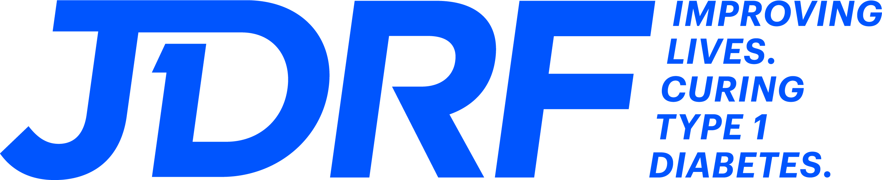
Thank you for your support!

